# Left Division vs Right Matrix Division – Matlab

written by [Tutorial45](https://tutorial45.com/author/bookenco/)

There are two operators allowing to divide in Matlab:

* The right division represented by the symbol / (slash)
* The left division represented by the symbol \ (Backslash)

These two operators differ from each other

Using numbers, the right division will be the conventional division we all day make use of, so

[matrix-division-matlab](https://cdn-0.tutorial45.com/wp-content/uploads/2015/07/matrix-division-matlab.png)

Contrary to the right division, the left division reverse the division, meaning

[matrix-division-matlab](https://cdn-0.tutorial45.com/wp-content/uploads/2015/07/matrix-division-matlab1.png)

## Matrix division in Matlab

### The right Matrix divide

Let’s consider two Matrices A and B

[matrix-division-matlab](https://cdn-0.tutorial45.com/wp-content/uploads/2015/07/matrix-division-matlab2.png)

Using the right division

[matrix-division-matlab](https://cdn-0.tutorial45.com/wp-content/uploads/2015/07/matrix-division-matlab3.png)

Matlab code

A=[1 2 ; 2 2];

B=[3 2 ; 1 1];

A/B % You can also use A*inv(B)

which returns

[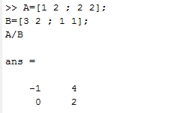](https://cdn-0.tutorial45.com/wp-content/uploads/2015/07/matrix-division-matlab4.png)

rewritten, it will look like this

[matrix-division-matlab](https://cdn-0.tutorial45.com/wp-content/uploads/2015/07/matrix-division-matlab5.png)

### The left Matrix divide

The right matrix divide is roughly the same as

[matrix-division-matlab](https://cdn-0.tutorial45.com/wp-content/uploads/2015/07/matrix-division-matlab6.png)

Which leads to a complete different result from the preceding operator.

This technique can be used to quickly compute the solution of the equation

[matrix-division-matlab](https://cdn-0.tutorial45.com/wp-content/uploads/2015/07/matrix-division-matlab7.png)

So, using our early defined matrices

[matrix-division-matlab](https://cdn-0.tutorial45.com/wp-content/uploads/2015/07/matrix-division-matlab8.png)

will be written

A=[1 2 ; 2 2];

B=[3 2 ; 1 1];

A\B % You can also use inv(A)*B

which returns

[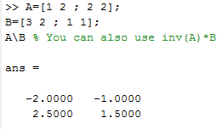](https://cdn-0.tutorial45.com/wp-content/uploads/2015/07/matrix-division-matlab9.png)

Which rewritten will look like

[matrix-division-matlab](https://cdn-0.tutorial45.com/wp-content/uploads/2015/07/matrix-division-matlab10.png)

## The Matrix division, element by element

We thought it will be also necessary you have a grip on the element-by-element Matrix division in Matlab

To divide Matrices, element-by-element, the following formula is useful

[matrix-division-matlab](https://cdn-0.tutorial45.com/wp-content/uploads/2015/07/matrix-division-matlab11.png)

Where

[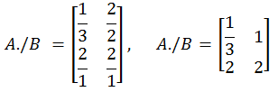](https://cdn-0.tutorial45.com/wp-content/uploads/2015/07/matrix-division-matlab12.png)

The code

A./B